

1 Home page

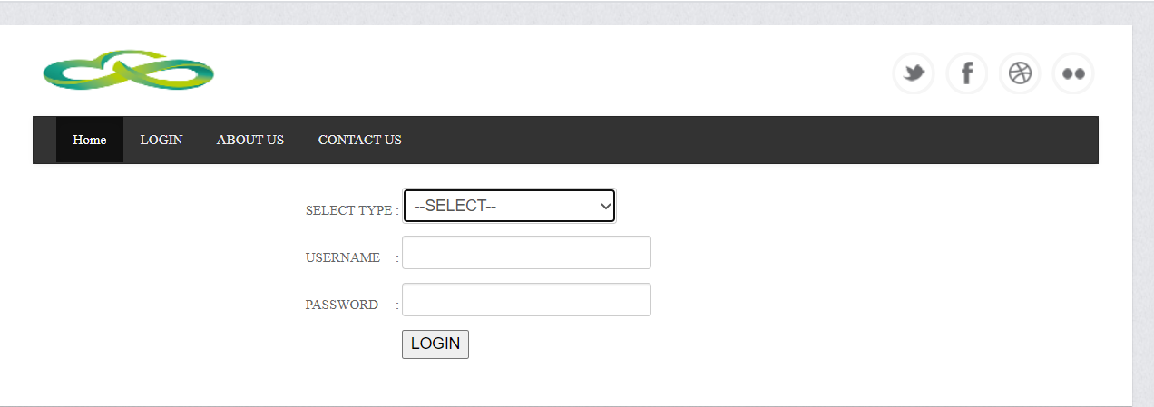

2) login

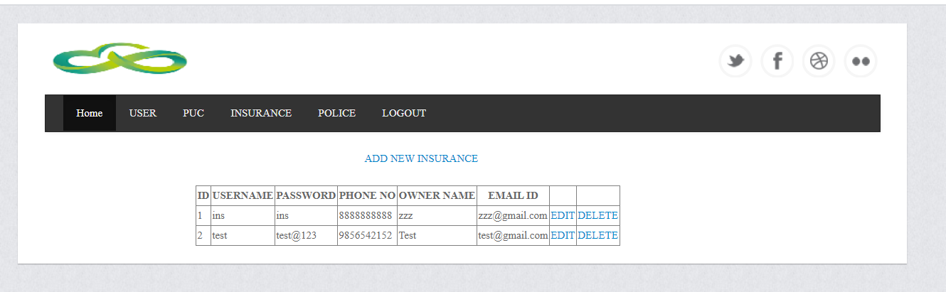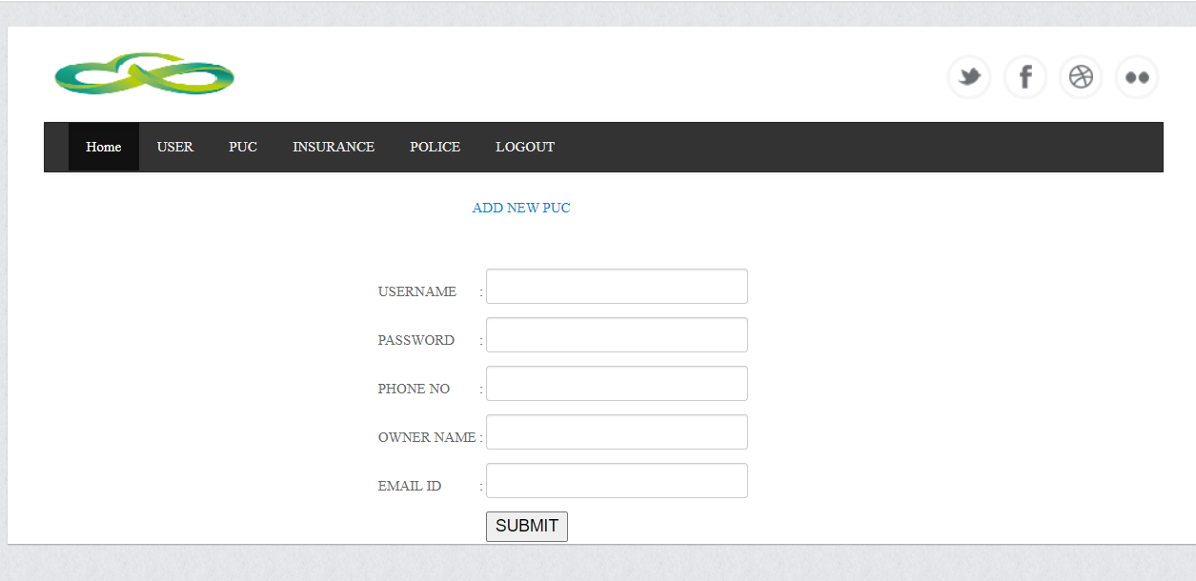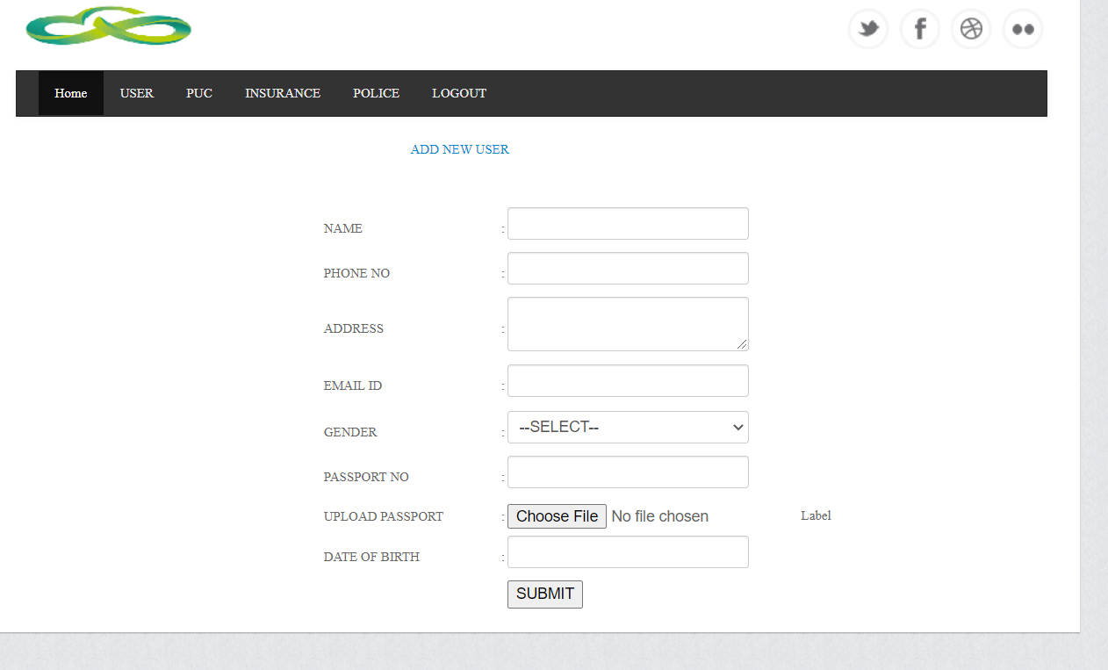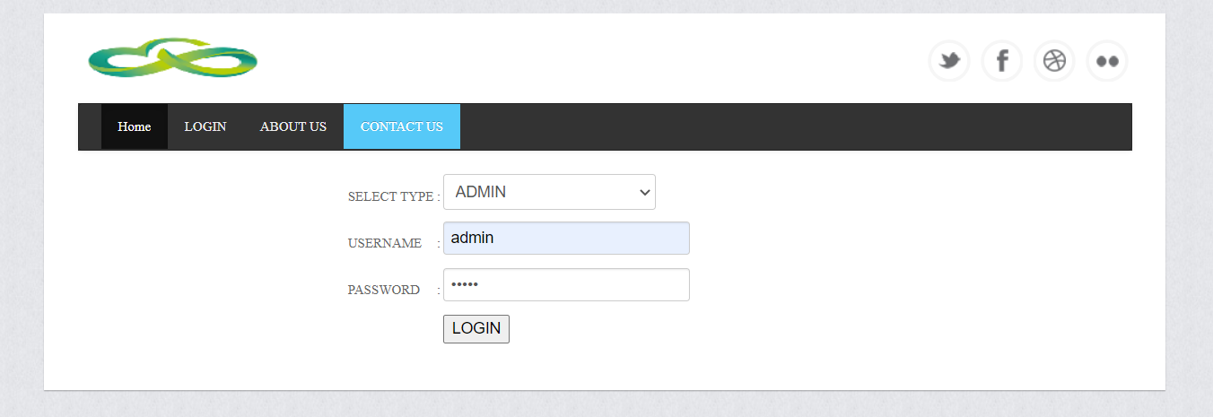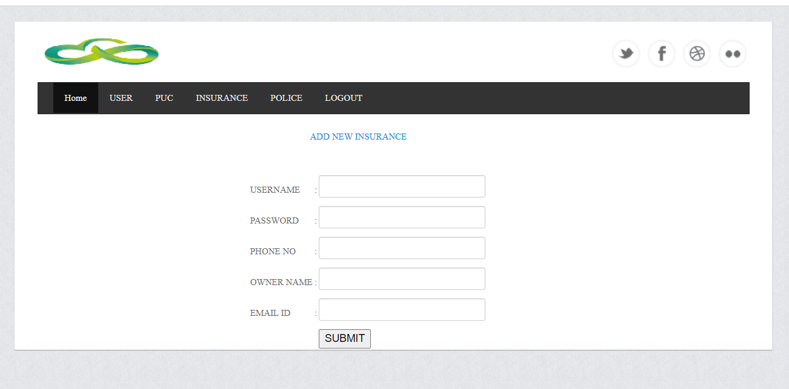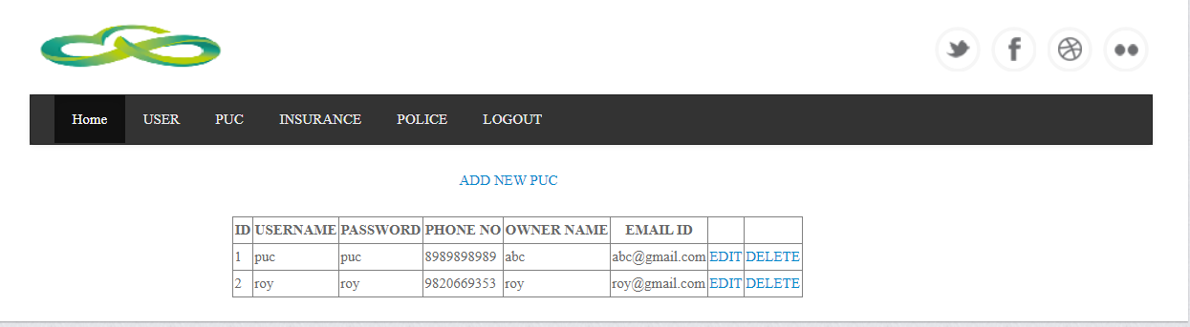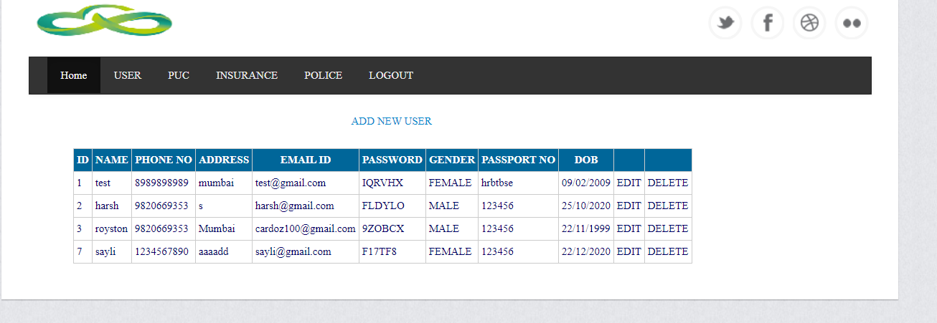

Code for home page:-

<%@ Page Title="" Language="C#" MasterPageFile="~/MasterPage.master" AutoEventWireup="true"

CodeFile="home.aspx.cs" Inherits="_Default" %>

<asp:Content ID="Content1" ContentPlaceHolderID="head" runat="Server">

</asp:Content>

<asp:Content ID="Content2" ContentPlaceHolderID="ContentPlaceHolder1" runat="Server">

<div class="slider">

<div class="flexslider">

<ul class="slides">

<li>

<img src="App_Themes/Theme1/img/slider/slider1.jpg" alt="" />

<div class="slide-caption n hidden-phone">

<%-- <h3>

This is a caption</h3>--%>

<p>

Cloud computing security or, more simply, cloud security refers to a broad set of

policies, technologies, and controls deployed to protect data, applications, and

the associated infrastructure of cloud computing. It is a sub-domain of computer

security, network security, and, more broadly, information security.

</p>

</div>

</li>

<li>

<img src="App_Themes/Theme1/img/slider/slider2.jpg" alt="" />

<div class="slide-caption hidden-phone">

<%-- <h3>

This is a caption</h3>--%>

<p>

Cloud computing and storage provides users with capabilities to store and process

their data in third-party data centers.Organizations use the cloud in a variety

of different service models (with acronyms such as SaaS, PaaS, and IaaS) and deployment

models (private, public, hybrid, and community).

</p>

</div>

</li>

<li>

<img src="App_Themes/Theme1/img/slider/slider3.jpg" alt="" />

</li>

</ul>

</div>

</div>

</asp:Content>

2) login page code

<%@ Page Title="" Language="C#" MasterPageFile="~/MasterPage.master" AutoEventWireup="true"

CodeFile="login.aspx.cs" Inherits="_Default" %>

<asp:Content ID="Content1" ContentPlaceHolderID="head" runat="Server">

<style type="text/css">

.auto-style1 {

height: 40px;

}

</style>

</asp:Content>

<asp:Content ID="Content2" ContentPlaceHolderID="ContentPlaceHolder1" runat="Server">

<div style="margin-left: 260px">

<table>

<tr>

<td class="auto-style1">

SELECT TYPE

</td>

<td class="auto-style1">

:

</td>

<td class="auto-style1">

<asp:DropDownList ID="DropDownList1" runat="server" Height="32px" Width="190px">

<asp:ListItem Value="0">--SELECT--</asp:ListItem>

<asp:ListItem Value="ADMIN">ADMIN</asp:ListItem>

<asp:ListItem Value="PUC">PUC</asp:ListItem>

<asp:ListItem Value="INSURANCE">INSURANCE</asp:ListItem>

</asp:DropDownList>

</td>

<td class="auto-style1">

<asp:RequiredFieldValidator ID="RequiredFieldValidator1" ControlToValidate="DropDownList1"

InitialValue="0" runat="server" ForeColor="Red" ErrorMessage="Select User Type"></asp:RequiredFieldValidator>

</td>

</tr>

<tr>

<td class="auto-style1">

USERNAME

</td>

<td class="auto-style1">

:

</td>

<td class="auto-style1">

<asp:TextBox ID="TextBox1" runat="server"></asp:TextBox>

</td>

<td class="auto-style1">

<asp:RequiredFieldValidator ID="RequiredFieldValidator2" runat="server" ForeColor="Red"

ControlToValidate="TextBox1" ErrorMessage="*"></asp:RequiredFieldValidator>

</td>

</tr>

<tr>

<td class="auto-style1">

PASSWORD

</td>

<td class="auto-style1">

:

</td>

<td class="auto-style1">

<asp:TextBox ID="TextBox2" runat="server" TextMode="Password"></asp:TextBox>

</td>

<td class="auto-style1">

<asp:RequiredFieldValidator ID="RequiredFieldValidator3" runat="server" ForeColor="Red"

ControlToValidate="TextBox2" ErrorMessage="*"></asp:RequiredFieldValidator>

</td>

</tr>

<tr>

<td>

</td>

<td>

</td>

<td>

<asp:Button ID="Button1" runat="server" Text="LOGIN" OnClick="Button1_Click" />

</td>

<td>

<asp:Label ID="Label1" runat="server" ForeColor="Red" Text="INVALID DETAILS"></asp:Label>

</td>

</tr>

</table>

</div>

<br />

<br />

</asp:Content>

3)log out

<%@ Page Title="" Language="C#" MasterPageFile="~/MasterPage.master" AutoEventWireup="true" CodeFile="logout.aspx.cs" Inherits="_Default" %>

<asp:Content ID="Content1" ContentPlaceHolderID="head" Runat="Server">

</asp:Content>

<asp:Content ID="Content2" ContentPlaceHolderID="ContentPlaceHolder1" Runat="Server">

</asp:Content>

4) Master page code

<%@ Master Language="C#" AutoEventWireup="true" CodeFile="MasterPage.master.cs" Inherits="MasterPage" %>

<!DOCTYPE html PUBLIC "-//W3C//DTD XHTML 1.0 Transitional//EN" "http://www.w3.org/TR/xhtml1/DTD/xhtml1-transitional.dtd">

<html xmlns="http://www.w3.org/1999/xhtml">

<head runat="server">

<asp:ContentPlaceHolder ID="head" runat="server">

<!-- start: Meta -->

<meta charset="utf-8">

<title>CLOUD BASED DOCUMENT SECURITY</title>

<meta name="description" content="FreeME:Bootstrap Theme" />

<meta name="keywords" content="Template, Theme, web, html5, css3" />

<meta name="author" content="Łukasz Holeczek from creativeLabs" />

<!-- end: Meta -->

<!-- start: Mobile Specific -->

<meta name="viewport" content="width=device-width, initial-scale=1, maximum-scale=1">

<!-- end: Mobile Specific -->

<!-- start: Facebook Open Graph -->

<meta property="og:title" content="" />

<meta property="og:description" content="" />

<meta property="og:type" content="" />

<meta property="og:url" content="" />

<meta property="og:image" content="" />

<!-- end: Facebook Open Graph -->

<!-- start: CSS -->

<link href="css/bootstrap.css" rel="stylesheet">

<link href="css/bootstrap-responsive.css" rel="stylesheet">

<link href="css/style.css" rel="stylesheet">

<link rel="stylesheet" type="text/css" href="http://fonts.googleapis.com/css?family=Droid+Sans:400,700">

<link rel="stylesheet" type="text/css" href="http://fonts.googleapis.com/css?family=Droid+Serif">

<link rel="stylesheet" type="text/css" href="http://fonts.googleapis.com/css?family=Boogaloo">

<link rel="stylesheet" type="text/css" href="http://fonts.googleapis.com/css?family=Economica:700,400italic">

<!-- end: CSS -->

<!-- Le HTML5 shim, for IE6-8 support of HTML5 elements -->

<!--[if lt IE 9]>

<script src="http://html5shim.googlecode.com/svn/trunk/html5.js"></script>

<![endif]-->

</asp:ContentPlaceHolder>

</head>

<body>

<form id="form1" runat="server">

<!--start: Wrapper -->

<div id="wrapper">

<!--start: Container -->

<div class="container">

<!--start: Header -->

<header>

<!--start: Row -->

<div class="row">

<!--start: Logo -->

<div class="logo span4">

<a class="brand" href="#"><img src="App_Themes/Theme1/img/logo.png"></a>

</div>

<!--end: Logo -->

<!--start: Social Links -->

<div class="span8">

<div id="social-links">

<ul class="social-small-grid">

<li>

<div class="social-small-item">

<div class="social-small-info-wrap">

<div class="social-small-info">

<div class="social-small-info-front social-small-twitter">

<a href="http://twitter.com"></a>

</div>

<div class="social-small-info-back social-small-twitter-hover">

<a href="http://twitter.com"></a>

</div>

</div>

</div>

</div>

</li>

<li>

<div class="social-small-item">

<div class="social-small-info-wrap">

<div class="social-small-info">

<div class="social-small-info-front social-small-facebook">

<a href="http://facebook.com"></a>

</div>

<div class="social-small-info-back social-small-facebook-hover">

<a href="http://facebook.com"></a>

</div>

</div>

</div>

</div>

</li>

<li>

<div class="social-small-item">

<div class="social-small-info-wrap">

<div class="social-small-info">

<div class="social-small-info-front social-small-dribbble">

<a href="http://dribbble.com"></a>

</div>

<div class="social-small-info-back social-small-dribbble-hover">

<a href="http://dribbble.com"></a>

</div>

</div>

</div>

</div>

</li>

<li>

<div class="social-small-item">

<div class="social-small-info-wrap">

<div class="social-small-info">

<div class="social-small-info-front social-small-flickr">

<a href="http://flickr.com"></a>

</div>

<div class="social-small-info-back social-small-flickr-hover">

<a href="http://flickr.com"></a>

</div>

</div>

</div>

</div>

</li>

</ul>

</div>

</div>

<!--end: Social Links -->

</div>

<!--end: Row -->

</header>

<!--end: Header-->

<!--start: Navigation-->

<div class="navbar navbar-inverse">

<div class="navbar-inner">

<div class="container">

<a class="btn btn-navbar" data-toggle="collapse" data-target=".nav-collapse"><span

class="icon-bar"></span><span class="icon-bar"></span><span class="icon-bar"></span>

</a>

<div class="nav-collapse collapse">

<ul class="nav">

<li class="active"><a href="home.aspx">Home</a></li>

<li><a href="login.aspx">LOGIN</a></li>

<li><a href="aboutus.aspx">ABOUT US</a></li>

<li><a href="contactus.aspx">CONTACT US</a></li>

</ul>

</div>

</div>

</div>

</div>

<!--end: Navigation-->

</div>

<!--end: Container-->

<!--start: Container -->

<div class="container">

<!-- start: Flexslider -->

<div class="row">

<asp:ContentPlaceHolder ID="ContentPlaceHolder1" runat="server">

</asp:ContentPlaceHolder>

</div>

<!-- end: Copyright -->

<!-- start: Java Script -->

<!-- Placed at the end of the document so the pages load faster -->

<script src="App_Themes/Theme1/js/jquery-1.8.2.js"></script>

<script src="App_Themes/Theme1/js/bootstrap.js"></script>

<script src="App_Themes/Theme1/js/flexslider.js"></script>

<script src="App_Themes/Theme1/js/carousel.js"></script>

<script def src="js/custom.js"></script>

<!-- end: Java Script -->

</form>

</body>

</html>

**4)add new user code**

<%@ Page Title="" Language="C#" MasterPageFile="~/admin/MasterPage.master" AutoEventWireup="true"

CodeFile="addnewuser.aspx.cs" Inherits="admin_Default" %>

<%@ Register Assembly="AjaxControlToolkit" Namespace="AjaxControlToolkit" TagPrefix="asp" %>

<asp:Content ID="Content1" ContentPlaceHolderID="head" runat="Server">

<style type="text/css">

.auto-style1 {

height: 42px;

}

.auto-style2 {

width: 160px;

}

.auto-style3 {

height: 42px;

width: 160px;

}

</style>

</asp:Content>

<asp:Content ID="Content2" ContentPlaceHolderID="ContentPlaceHolder1" runat="Server">

<div style="margin-left: 380px">

<asp:LinkButton ID="LinkButton1" runat="server" OnClick="LinkButton1_Click">ADD NEW USER</asp:LinkButton>

</div>

<br />

<div style="margin-left: 70px">

<asp:GridView ID="GridView1" OnRowCommand="RowCommand" runat="server" AutoGenerateColumns="False"

BackColor="White" BorderColor="#CCCCCC" BorderStyle="None" BorderWidth="1px"

CellPadding="3">

<Columns>

<asp:BoundField HeaderText="ID" DataField="id" />

<asp:BoundField HeaderText="NAME" DataField="name" />

<asp:BoundField HeaderText="PHONE NO" DataField="phone_" />

<asp:BoundField HeaderText="ADDRESS" DataField="address" />

<asp:BoundField HeaderText="EMAIL ID" DataField="email_id" />

<asp:BoundField HeaderText="PASSWORD" DataField="password" />

<asp:BoundField HeaderText="GENDER" DataField="gender" />

<asp:BoundField HeaderText="PASSPORT NO" DataField="licence_no" />

<%--<asp:BoundField HeaderText="VEHICLE NO" DataField="vehicle_no" />--%>

<asp:BoundField HeaderText="DOB" DataField="date_ob" />

<asp:ButtonField Text="EDIT" CommandName="edit_" />

<asp:ButtonField Text="DELETE" CommandName="delete_" />

</Columns>

<FooterStyle BackColor="White" ForeColor="#000066" />

<HeaderStyle BackColor="#006699" Font-Bold="True" ForeColor="White" />

<PagerStyle BackColor="White" ForeColor="#000066" HorizontalAlign="Left" />

<RowStyle ForeColor="#000066" />

<SelectedRowStyle BackColor="#669999" Font-Bold="True" ForeColor="White" />

<SortedAscendingCellStyle BackColor="#F1F1F1" />

<SortedAscendingHeaderStyle BackColor="#007DBB" />

<SortedDescendingCellStyle BackColor="#CAC9C9" />

<SortedDescendingHeaderStyle BackColor="#00547E" />

</asp:GridView>

</div>

<br />

<div style="margin-left: 300px">

<table runat="server" id="tbl1">

<tr>

<td class="auto-style2">

<asp:Label ID="user_id" runat="server" Text=""></asp:Label>

</td>

</tr>

<tr>

<td class="auto-style2">

NAME

</td>

<td>

:

</td>

<td>

<asp:TextBox ID="txtName" runat="server"></asp:TextBox>

</td>

<td>

<asp:RequiredFieldValidator ID="RequiredFieldValidator1" runat="server" ErrorMessage="*"

ForeColor="Red" ControlToValidate="txtName"></asp:RequiredFieldValidator>

</td>

</tr>

<tr>

<td class="auto-style2">

PHONE NO

</td>

<td>

:

</td>

<td>

<asp:TextBox ID="txtPhNumber" runat="server" MaxLength="10"></asp:TextBox>

</td>

<td>

<asp:RequiredFieldValidator ID="RequiredFieldValidator2" runat="server" ErrorMessage="*"

ForeColor="Red" ControlToValidate="txtPhNumber"></asp:RequiredFieldValidator>

</td>

<td>

<asp:RegularExpressionValidator ControlToValidate="txtPhNumber" ID="RegularExpressionValidator1"

runat="server" ErrorMessage="only numbers" ForeColor="Red" ValidationExpression="^\d+$"></asp:RegularExpressionValidator>

</td>

</tr>

<tr>

<td class="auto-style2">

ADDRESS

</td>

<td>

:

</td>

<td>

<asp:TextBox ID="ttxtAddress" TextMode="MultiLine" runat="server"></asp:TextBox>

</td>

<td>

<asp:RequiredFieldValidator ID="RequiredFieldValidator3" runat="server" ErrorMessage="*"

ForeColor="Red" ControlToValidate="ttxtAddress"></asp:RequiredFieldValidator>

</td>

</tr>

<tr>

<td class="auto-style3">

EMAIL ID

</td>

<td class="auto-style1">

:

</td>

<td class="auto-style1">

<asp:TextBox ID="txtEmail" runat="server"></asp:TextBox>

</td>

<td class="auto-style1">

<asp:RequiredFieldValidator ID="RequiredFieldValidator4" runat="server" ErrorMessage="*"

ForeColor="Red" ControlToValidate="txtEmail"></asp:RequiredFieldValidator>

</td>

<td class="auto-style1">

<asp:RegularExpressionValidator ID="RegularExpressionValidator2" runat="server" ControlToValidate="txtEmail"

ForeColor="Red" ErrorMessage="Invalid email" ValidationExpression="^([\w\.\-]+)@([\w\-]+)((\.(\w){2,3})+)$"></asp:RegularExpressionValidator>

</td>

</tr>

<tr>

<td class="auto-style2">

GENDER

</td>

<td>

:

</td>

<td>

<asp:DropDownList ID="DropDownList1" runat="server">

<asp:ListItem Value="0">--SELECT--</asp:ListItem>

<asp:ListItem Value="MALE">MALE</asp:ListItem>

<asp:ListItem Value="FEMALE">FEMALE</asp:ListItem>

</asp:DropDownList>

</td>

<td>

<asp:RequiredFieldValidator ID="RequiredFieldValidator5" runat="server" ErrorMessage="*"

ForeColor="Red" InitialValue="0" ControlToValidate="DropDownList1"></asp:RequiredFieldValidator>

</td>

</tr>

<tr>

<td class="auto-style2">

PASSPORT NO

</td>

<td>

:

</td>

<td>

<asp:TextBox ID="txtPasspportNumber" runat="server"></asp:TextBox>

</td>

<td>

<asp:RequiredFieldValidator ID="RequiredFieldValidator6" runat="server" ErrorMessage="*"

ForeColor="Red" ControlToValidate="txtPasspportNumber"></asp:RequiredFieldValidator>

</td>

</tr>

<%-- <tr>

<td>

VEHICLE NO

</td>

<td>

:

</td>

<td>

<asp:TextBox ID="TextBox6" runat="server"></asp:TextBox>

</td>

<td>

<asp:RequiredFieldValidator ID="RequiredFieldValidator7" runat="server" ErrorMessage="*"

ForeColor="Red" ControlToValidate="TextBox6"></asp:RequiredFieldValidator>

</td>

</tr>--%>

<tr>

<td class="auto-style2">

UPLOAD PASSPORT

</td>

<td>

:

</td>

<td>

<asp:FileUpload ID="FileUpload1" runat="server" />

<asp:Label ID="Label1" runat="server" Text="Label"></asp:Label>

</td>

<td>

&nbsp;</td>

</tr>

<tr>

<td class="auto-style2">

DATE OF BIRTH

</td>

<td>

:

</td>

<td>

<asp:ToolkitScriptManager ID="toolScriptManageer1" runat="server">

</asp:ToolkitScriptManager>

<asp:TextBox ID="txtdate" runat="server"></asp:TextBox>

<asp:CalendarExtender ID="CalendarExtender1" runat="server" TargetControlID="txtdate"

Format="dd/MM/yyyy">

</asp:CalendarExtender>

</td>

<td>

<asp:RequiredFieldValidator ID="RequiredFieldValidator8" runat="server" ForeColor="Red"

ControlToValidate="txtdate" ErrorMessage="*"></asp:RequiredFieldValidator>

</td>

</tr>

<tr>

<td class="auto-style2">

</td>

<td>

</td>

<td>

<asp:Button ID="Button1" runat="server" Text="SUBMIT" OnClick="Button1_Click" />

<asp:Button ID="Button2" runat="server" Text="UPDATE" onclick="Button2_Click" />

</td>

</tr>

</table>

</div>

<br />

**5)insuarance code**

<%@ Page Title="" Language="C#" MasterPageFile="~/admin/MasterPage.master" AutoEventWireup="true" CodeFile="ins.aspx.cs" Inherits="admin_Default" %>

<asp:Content ID="Content1" ContentPlaceHolderID="head" Runat="Server">

</asp:Content>

<asp:Content ID="Content2" ContentPlaceHolderID="ContentPlaceHolder1" Runat="Server">

<div style="margin-left: 380px">

<asp:LinkButton ID="LinkButton1" runat="server" OnClick="LinkButton1_Click">ADD NEW INSURANCE</asp:LinkButton>

</div>

<br />

<div style="margin-left: 190px">

<asp:GridView ID="GridView1" runat="server" OnRowCommand="RowCommand" AutoGenerateColumns="false">

<Columns>

<asp:BoundField HeaderText="ID" DataField="id" />

<asp:BoundField HeaderText="USERNAME" DataField="username" />

<asp:BoundField HeaderText="PASSWORD" DataField="password" />

<asp:BoundField HeaderText="PHONE NO" DataField="phone_no" />

<asp:BoundField HeaderText="OWNER NAME" DataField="owner_name" />

<asp:BoundField HeaderText="EMAIL ID" DataField="email_id" />

<asp:ButtonField Text="EDIT" CommandName="Edit_" />

<asp:ButtonField Text="DELETE" CommandName="Delete_" />

</Columns>

</asp:GridView>

</div>

<br />

<div style="margin-left: 300px">

<table runat="server" id="tbl1">

<tr>

<td>

USERNAME

</td>

<td>

:

</td>

<td>

<asp:TextBox ID="TextBox1" runat="server"></asp:TextBox>

</td>

<td>

<asp:RequiredFieldValidator ID="RequiredFieldValidator1" runat="server" ErrorMessage="*"

ForeColor="Red" ControlToValidate="TextBox1"></asp:RequiredFieldValidator>

</td>

</tr>

<tr>

<td>

PASSWORD

</td>

<td>

:

</td>

<td>

<asp:TextBox ID="TextBox2" runat="server"></asp:TextBox>

</td>

<td>

<asp:RequiredFieldValidator ID="RequiredFieldValidator2" runat="server" ErrorMessage="*"

ForeColor="Red" ControlToValidate="TextBox2"></asp:RequiredFieldValidator>

</td>

</tr>

<tr>

<td>

PHONE NO

</td>

<td>

:

</td>

<td>

<asp:TextBox ID="TextBox3" runat="server"></asp:TextBox>

</td>

<td>

<asp:RequiredFieldValidator ID="RequiredFieldValidator3" runat="server" ErrorMessage="*"

ForeColor="Red" ControlToValidate="TextBox3"></asp:RequiredFieldValidator>

</td>

</tr>

<tr>

<td>

OWNER NAME

</td>

<td>

:

</td>

<td>

<asp:TextBox ID="TextBox4" runat="server"></asp:TextBox>

</td>

<td>

<asp:RequiredFieldValidator ID="RequiredFieldValidator4" runat="server" ErrorMessage="*"

ForeColor="Red" ControlToValidate="TextBox4"></asp:RequiredFieldValidator>

</td>

</tr>

<tr>

<td>

EMAIL ID

</td>

<td>

:

</td>

<td>

<asp:TextBox ID="TextBox5" runat="server"></asp:TextBox>

</td>

<td>

<asp:RequiredFieldValidator ID="RequiredFieldValidator5" runat="server" ErrorMessage="*"

ForeColor="Red" ControlToValidate="TextBox5"></asp:RequiredFieldValidator>

</td>

</tr>

<tr>

<td>

</td>

<td>

</td>

<td>

<asp:Button ID="Button1" runat="server" Text="SUBMIT" onclick="Button1_Click" />

<asp:Button ID="Button2" runat="server" Text="UPDATE" onclick="Button2_Click" />

</td>

</tr>

</table>

</div>

</asp:Content>

**6)puc code**

<%@ Page Title="" Language="C#" MasterPageFile="~/admin/MasterPage.master" AutoEventWireup="true"

CodeFile="puc.aspx.cs" Inherits="admin_Default" %>

<asp:Content ID="Content1" ContentPlaceHolderID="head" runat="Server">

</asp:Content>

<asp:Content ID="Content2" ContentPlaceHolderID="ContentPlaceHolder1" runat="Server">

<div style="margin-left: 380px">

<asp:LinkButton ID="LinkButton1" runat="server" OnClick="LinkButton1_Click">ADD NEW PUC</asp:LinkButton>

</div>

<br />

<div style="margin-left: 190px">

<asp:GridView ID="GridView1" runat="server" OnRowCommand="RowCommand" AutoGenerateColumns="false">

<Columns>

<asp:BoundField HeaderText="ID" DataField="id" />

<asp:BoundField HeaderText="USERNAME" DataField="username" />

<asp:BoundField HeaderText="PASSWORD" DataField="password" />

<asp:BoundField HeaderText="PHONE NO" DataField="phone_no" />

<asp:BoundField HeaderText="OWNER NAME" DataField="owner_name" />

<asp:BoundField HeaderText="EMAIL ID" DataField="email_id" />

<asp:ButtonField Text="EDIT" CommandName="Edit_" />

<asp:ButtonField Text="DELETE" CommandName="Delete_" />

</Columns>

</asp:GridView>

</div>

<br />

<div style="margin-left: 300px">

<table runat="server" id="tbl1">

<tr>

<td>

USERNAME

</td>

<td>

:

</td>

<td>

<asp:TextBox ID="TextBox1" runat="server"></asp:TextBox>

</td>

<td>

<asp:RequiredFieldValidator ID="RequiredFieldValidator1" runat="server" ErrorMessage="*"

ForeColor="Red" ControlToValidate="TextBox1"></asp:RequiredFieldValidator>

</td>

</tr>

<tr>

<td>

PASSWORD

</td>

<td>

:

</td>

<td>

<asp:TextBox ID="TextBox2" runat="server"></asp:TextBox>

</td>

<td>

<asp:RequiredFieldValidator ID="RequiredFieldValidator2" runat="server" ErrorMessage="*"

ForeColor="Red" ControlToValidate="TextBox2"></asp:RequiredFieldValidator>

</td>

</tr>

<tr>

<td>

PHONE NO

</td>

<td>

:

</td>

<td>

<asp:TextBox ID="TextBox3" runat="server"></asp:TextBox>

</td>

<td>

<asp:RequiredFieldValidator ID="RequiredFieldValidator3" runat="server" ErrorMessage="*"

ForeColor="Red" ControlToValidate="TextBox3"></asp:RequiredFieldValidator>

</td>

</tr>

<tr>

<td>

OWNER NAME

</td>

<td>

:

</td>

<td>

<asp:TextBox ID="TextBox4" runat="server"></asp:TextBox>

</td>

<td>

<asp:RequiredFieldValidator ID="RequiredFieldValidator4" runat="server" ErrorMessage="*"

ForeColor="Red" ControlToValidate="TextBox4"></asp:RequiredFieldValidator>

</td>

</tr>

<tr>

<td>

EMAIL ID

</td>

<td>

:

</td>

<td>

<asp:TextBox ID="TextBox5" runat="server"></asp:TextBox>

</td>

<td>

<asp:RequiredFieldValidator ID="RequiredFieldValidator5" runat="server" ErrorMessage="*"

ForeColor="Red" ControlToValidate="TextBox5"></asp:RequiredFieldValidator>

</td>

</tr>

<tr>

<td>

</td>

<td>

</td>

<td>

<asp:Button ID="Button1" runat="server" Text="SUBMIT" onclick="Button1_Click" />

<asp:Button ID="Button2" runat="server" Text="UPDATE" onclick="Button2_Click" />

</td>

</tr>

</table>

</div>

</asp:Content>

**Insurance database**

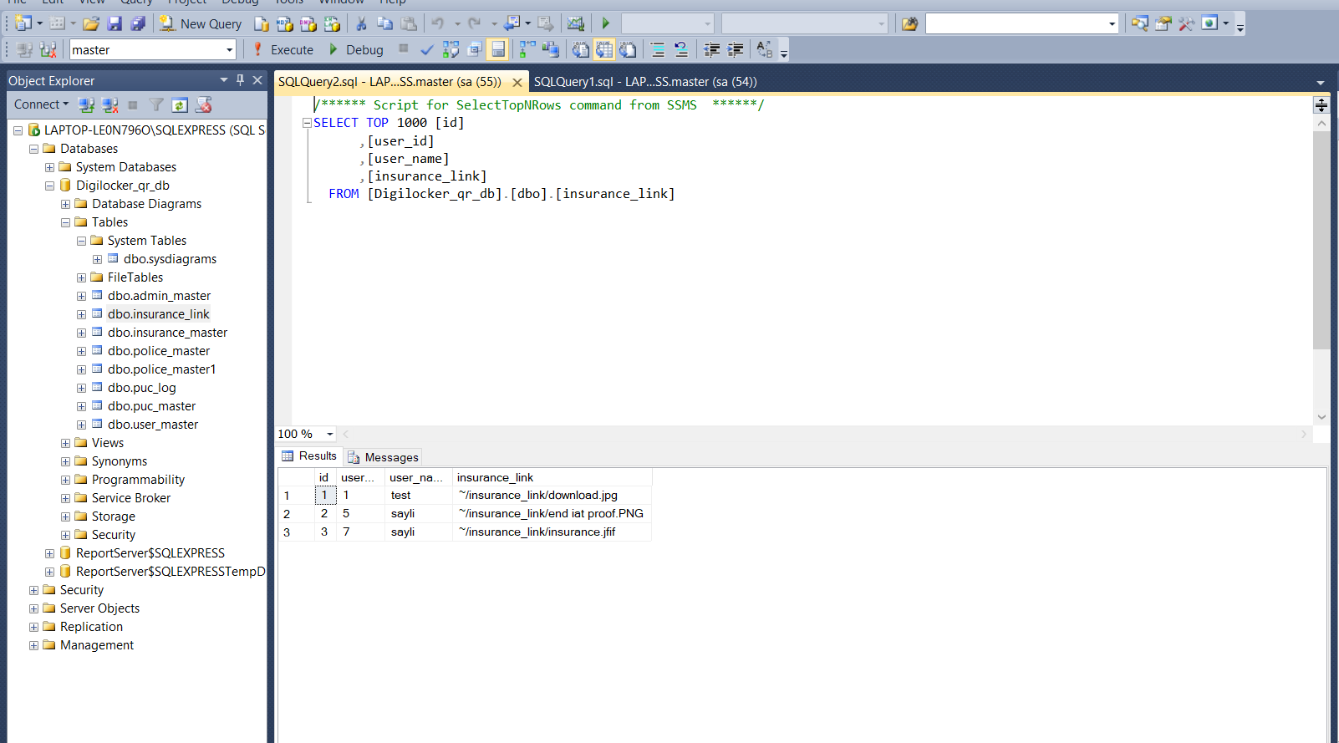

**Puc database**

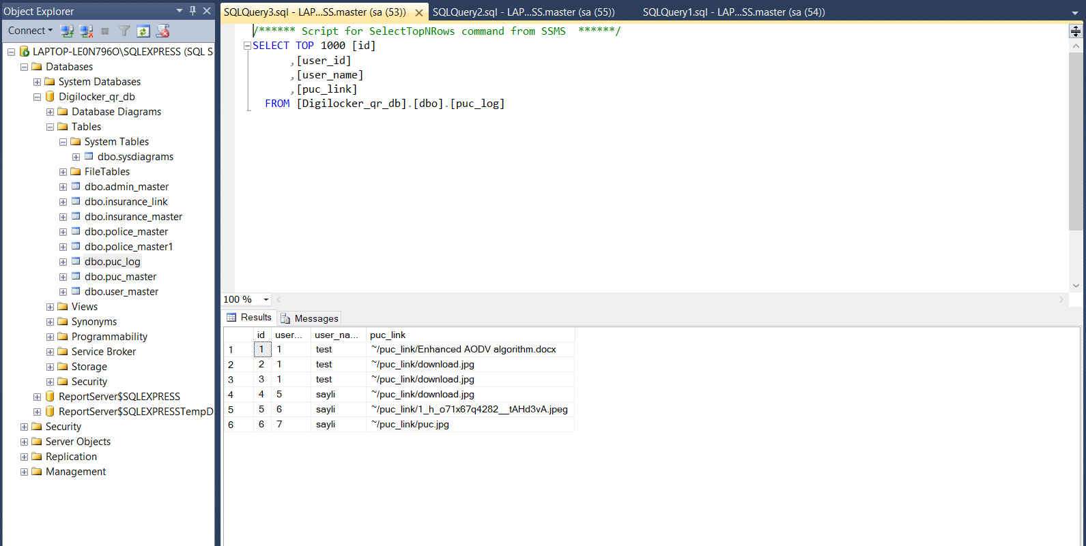

**Admin database**

